AlgoAlpha

A Mini-Project Report
Under
Implementation of Technology

Submitted by

N001 – Kashika Agarwal
N002 – Nidhi Agarwal
N011 – Jeel Chaniyara
N017 – Abhi Kapadia

Under The Guidance Of

Ratnesh Chaturvedi

in partial fulfillment for the award of the degree
of
Master of Business Administration Technology
IN
Computers
at

Mukesh patel school of technology management and engineering, mumbai
April, 2016

Annexure-II
CERTIFICATE
This is to certify that the project entitled AlgoAlpha is the bonafide work carried out by Kashika Agarwal, Nidhi Agarwal, Jeel Chaniyara and Abhi Kapadia MBATech (Computer Engineering), MPSTME (NMIMS), Mumbai, during the fourth semester of the academic year 2015-2016, in fulfillment of the requirements for the award of the Degree of Masters of Business Administration Technology as per the norms prescribed by NMIMS. The project work has been assessed and found to be satisfactory.

___________________
Ratnesh Chaturvedi
Internal Mentor

_______________________ ________________________
Examiner 1 Examiner 2

________________________
Dean
Dr. Sharad Y. Mhaiskar

Annexure-III
DECLARATION
We, Kashika Agarwal, Nidhi Agarwal, Jeel Chaniyara, and Abhi Kapadia, MBATech (Computer Engineering), semester- IV, understand that plagiarism is defined as anyone or combination of the following:

1. Un-credited verbatim copying of individual sentences, paragraphs or illustration (such as graphs, diagrams, etc.) from any source, published or unpublished, including the internet.

2. Un-credited improper paraphrasing of pages paragraphs (changing a few words phrases, or rearranging the original sentence order)

3. Credited verbatim copying of a major portion of a paper (or thesis chapter) without clear delineation of who did wrote what.

4. We have made sure that all the ideas, expressions, graphs, diagrams, etc., that are not a result of our work, are properly credited. Long phrases or sentences that had to be used verbatim from published literature have been clearly identified using quotation marks.

5. We affirm that no portion of my work can be considered as plagiarism and we take full responsibility if such a complaint occurs. We understand fully well that the guide of the seminar/ seminar report may not be in a position to check for the possibility of such incidences of plagiarism in this body of work.

Students’
Signature: ___________ ____________ ___________ ____________
Name: ___________ ____________ ___________ ____________
Roll No.: ___________ ____________ ___________ ____________
Place: Mumbai
Date: April 2016

ACKNOWLEDGMENT

We take this opportunity to express our sincere deference and gratitude to Prof. Ratnesh Chaturvedi for his constant guidance and motivation provided during the course of this work. It was a unique privilege to work under his valuable guidance and supervision. Also my H.O.D, Dr. Dhirendra Mishra for encouraging me to perform the seminar work and Dean Dr. Sharad Y. Mhaiskar for providing such platform.
We also like to wish our immense gratitude to all the authors of the papers whose reference has made this presentation and report possible reality.
We convey our gratitude to all who’s directly or indirectly involvement and valuable suggestions helped me and hope for further inputs in the future.
We would also like to take this opportunity to thank MPSTME library, and resource for providing with all the research papers, data, archives and other reference in a timely manner.

Annexure IV
Table of contents
CHAPTER NO. TITLE PAGE NO.
List of Figures i
List of Tables ii
Abbreviations iii
Abstract iv
1. INTRODUCTION
1.1 Project Overview
1.2 Hardware Specification
1.3 Software Specification
2. REVIEW OF LITERATURE
3. ANALYSIS & DESIGN
4. METHODS IMPLEMENTED
5. RESULTS & DISCUSSION
6. CONCLUSION & FUTURE SCOPE
REFERENCES
APPENDIX

Annexure V
List of Figures
CHAPTER NO. TITLE PAGE NO.
1. INTRODUCTION
Fig 1 Android Architecture Diagram
3. ANALYSIS AND DESIGN
Fig 2 Home Screen
Fig 3 Navigation Bar
Fig 4 Sorting Algorithm Landing
Fig 5.1 Selection Sort Landing (Algorithm Hidden)
Fig 5.2 Selection Sort Landing (Algorithm Shown)

*************
Annexure VI
Abbreviations
Abbreviation Description
ADB | Android Debugging Bridge
ADT | Android Development Tools
Android SDK | Android Software Development Kit
ART | Android Runtime
CPU | Central Processing Unit
GPU | Graphic Processing Unit
IPS | In-Plane Switching
LCD | Liquid Crystal Display
RAM | Random Access Memory
SQL | Structured Query Language
XML | Extensible Markup Language

ABSTRACT

Modern hand held devices such as smart phones and PDAs have become increasingly powerful in recent years. Dramatic breakthroughs in processing power along with the number of extra features included in these devices have opened the doors to a wide range of commercial possibilities. In particular, most cell phones regularly include cameras, processors comparable to PCs from only a few years ago, and internet access. However, even with all these added abilities, there are few applications that allow much passing of the environmental information and location based services.

As mobile devices become more like PCs they will come to replace objects we tend to carry around such as checkbooks, credit cards, cameras, planners, mp3 players, etc. In short, we will be using them to accomplish our daily tasks. One application that falls into this category is the AlgoAlpha developed for Android Phones.

The prime objective of AlgoAlpha is to create a full-fledged Android application that enables and helps users access a database of algorithms which are used in modern computing world. The users can access this database directly without any login procedures. The user can also get the code of the required algorithm in C, C++, and Java. Should the user want an algorithm that is not included in the database, they can request for it via the application too.

The Project is developed in Java Programming Language by using the Android Studio Integrated Development Environment (IDE). We used the Android Software Development Kit (SDK) which includes a variety of custom tools that help us develop mobile applications on the Android platform. The most important of these are the Android Emulator, HXAM Accelerator and the Android Development Tools (ADT) packages for Android Studio.

INTRODUCTION

Introduction to Android:
Android is an open source and Linux-based operating system for mobile devices such as smart phones and tablet computers. Android was developed by the Open Handset Alliance, led by Google, and other companies.

Android provides a rich application framework that allows you to build innovative apps and games for mobile devices in a Java language environment.

Android Architecture:
Android operating system is a stack of software components which is roughly divided into five sections and four main layers as shown below in the architecture diagram.

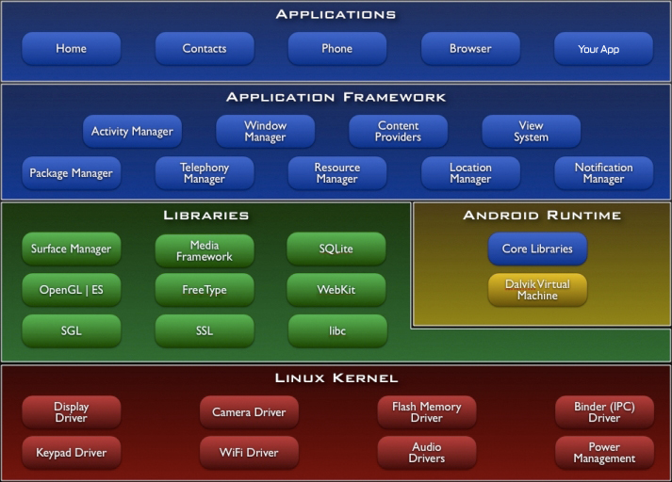
Fig 1.1

Android gives you a world-class platform for creating apps and games for Android users everywhere, as well as an open marketplace for distributing to them instantly. Android operating system is a stack of software components which is roughly divided into five sections and four main layers as shown below in the architecture diagram.
You will find all the Android application at the top layer. You will write your application to be installed on this layer only. Examples of such applications are Contacts Books, Browser, Games etc. These comprise both the native applications provided with the particular Android implementation (for example web browser and email applications) and the third party applications installed by the user after purchasing the device. Applications created by third party users or developers will be installed here.
Introduction to Application:

AlgoAlpha is an application on the android platform that enables and helps users access an enormous database of algorithms which are used in the modern computing world.

The application’s purpose is to promote coding knowledge by giving access to a wide array of population to the concepts of computing used in the industry. Not only does the application explain the algorithm, it also showcases code for it in C, C++ and Java.

The app is useful for anyone who wishes to pursue coding and allows them to learn algorithms of many different sections. For example, Tree based, array based, linked list based, etc.

The application can also help users request algorithms should they not find them in this database.

Project Overview:

AlgoAlpha is a developing android application that will power fast & convenient way for its users to be up to date with programming concepts used in the industry. We at Team AlgoAlpha aim to build a platform for simplified learning of algorithms which can be applied in real-time.

Hardware Specification

AlgoAlpha is not a hardware intensive application, thus requires very basic level of hardware, as its application ranges across all devices, low end to high end, phones to tablets. Thus, the following are the minimum hardware specifications required to run the application:
- Processor:
  - Dual-core 1.0 GHz
- Memory:
  - 768 MB RAM
  - 4 MB of Flash Memory
- Screen:
  - 3.5-inch LCD display
  - Capacitive or Resistive touch

During Development of the application, the following handsets were used to develop and test the application:
- Xiaomi Mi4i
- Sony Ericsson Live With Walkman (WT19i)
- Sony Xperia C
- LG Nexus 6
- Oneplus 2
- Samsung Galaxy S4
- Samsung Galaxy Note 3 Neo
- Motorola Moto G
- Motorola Moto G2
- Motorola Moto G3

Software Specification

AlgAlpha is designed to work on Android 2.3, Gingerbread and above.
Apart from Android 2.3 and above, the application, like most android applications can run on the following Operating Systems:
- Blackberry OS 11
- Sailfish OS
- Chrome OS
- Color OS
- INUI OS
- YUN OS
- Nokia X mobile Platform

Some of these are based on android, while some (Bbos 11, Sailfish OS) are made compatible to run android applications. Following is the list of Android versions on which AlgoAlpha has been tested:
- Android 2.3 (Gingerbread)
- Android 4.0 (Ice Cream Sandwich)
- Android 4.2 (Jellybean)
- Android 4.3 (Jellybean)
- Android 4.4 (KitKat)
- Android 5.0 (Lollipop)
- Android 5.0.2 (Lollipop)
- Android 5.1 (Lollipop)
- Android 6.0 (Marshmallow)

This gives the application a broad platform, as these operating systems are in majority of smart phones being used by prospective users.
The application needs a stable internet connection to access the database.
Review of Literature

A literature review is a text of a scholarly paper, which includes the current knowledge including substantive findings, as well as theoretical and methodological contributions to a particular topic. Most often associated with academic-oriented literature, such as a thesis, dissertation or a peer-reviewed journal article, a literature review usually precedes the methodology and results section although this is not always the case. Literature reviews are also common in a research proposal or prospectus. Its main goals are to situate the current study within the body of literature and to provide context for the particular reader. Literature reviews are a basis for research in nearly every academic field.

Java:
Java is a set of several computer software and specifications developed by Sun. Microsystems, later acquired by Oracle Corporation that provides a system for developing application software and deploying it in a cross-platform computing environment. Java is used in a wide variety of computing platforms from embedded devices and mobile phones to enterprise servers and supercomputers. While less common, Java applets run in secure, sandboxed environments to provide many features of native applications and can be embedded in HTML pages.
Writing in the Java programming language is the primary way to produce code that will be deployed as byte code in a Java Virtual Machine (JVM); byte code compilers are also available for other languages, including Ada, JavaScript, Python, and Ruby. In addition, several languages have been designed to run natively on the JVM, including Scala, Clojure and Groovy. Java syntax borrows heavily from C and C++, but object-oriented features are modeled after Smalltalk and Objective-C.Java eschews certain low-level constructs such as pointers and has a very simple memory model where every object is allocated on the heap and all variables of object types are references. Memory management is handled through integrated automatic garbage collection performed by the JVM.

ANALYSIS & DESIGN

During the conception of the application, the requirements were mapped out first. This included analyzing the need of this application, its features and figuring out a list of functions it would perform during operation. This largely consisted of the analysis.
After performing a complete analysis, the design of the application was pursued. Abnegate was designed using material design. Material design is a comprehensive guide for visual, motion, and interaction design across platforms and devices.

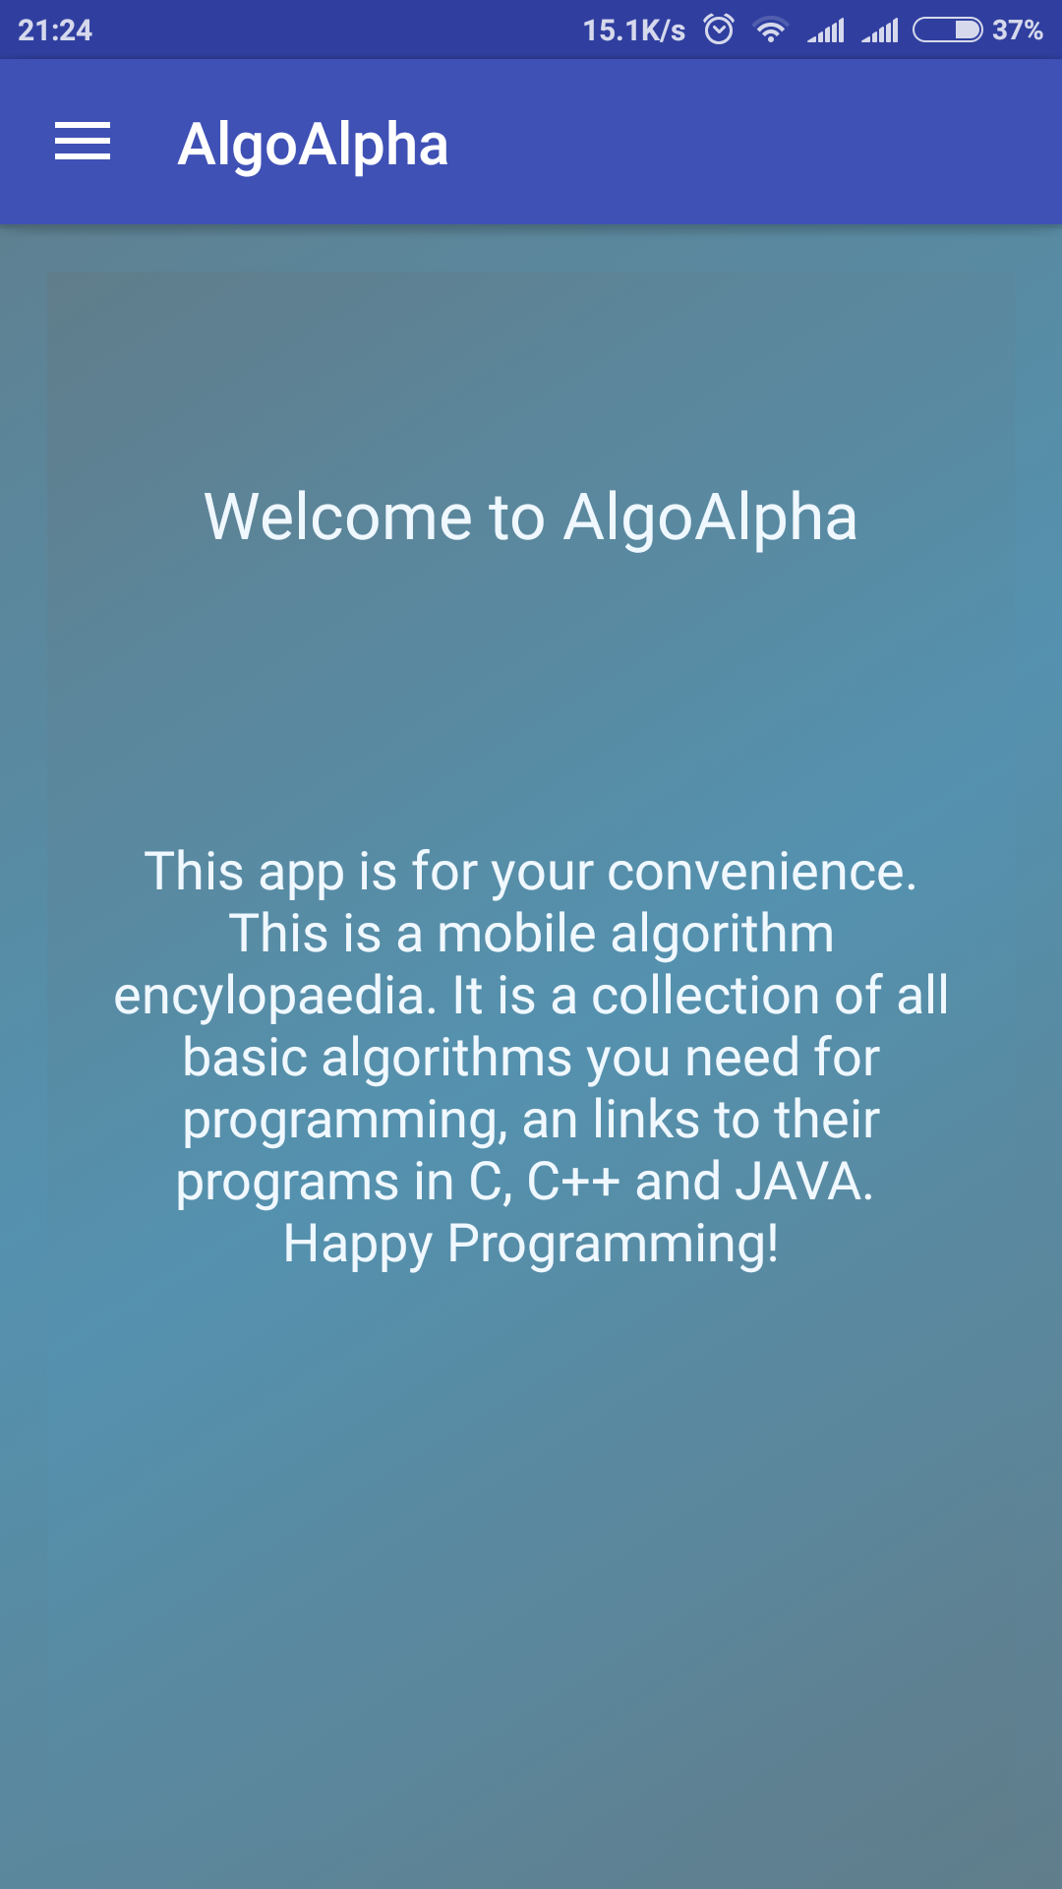
Figure 2: Home Screen
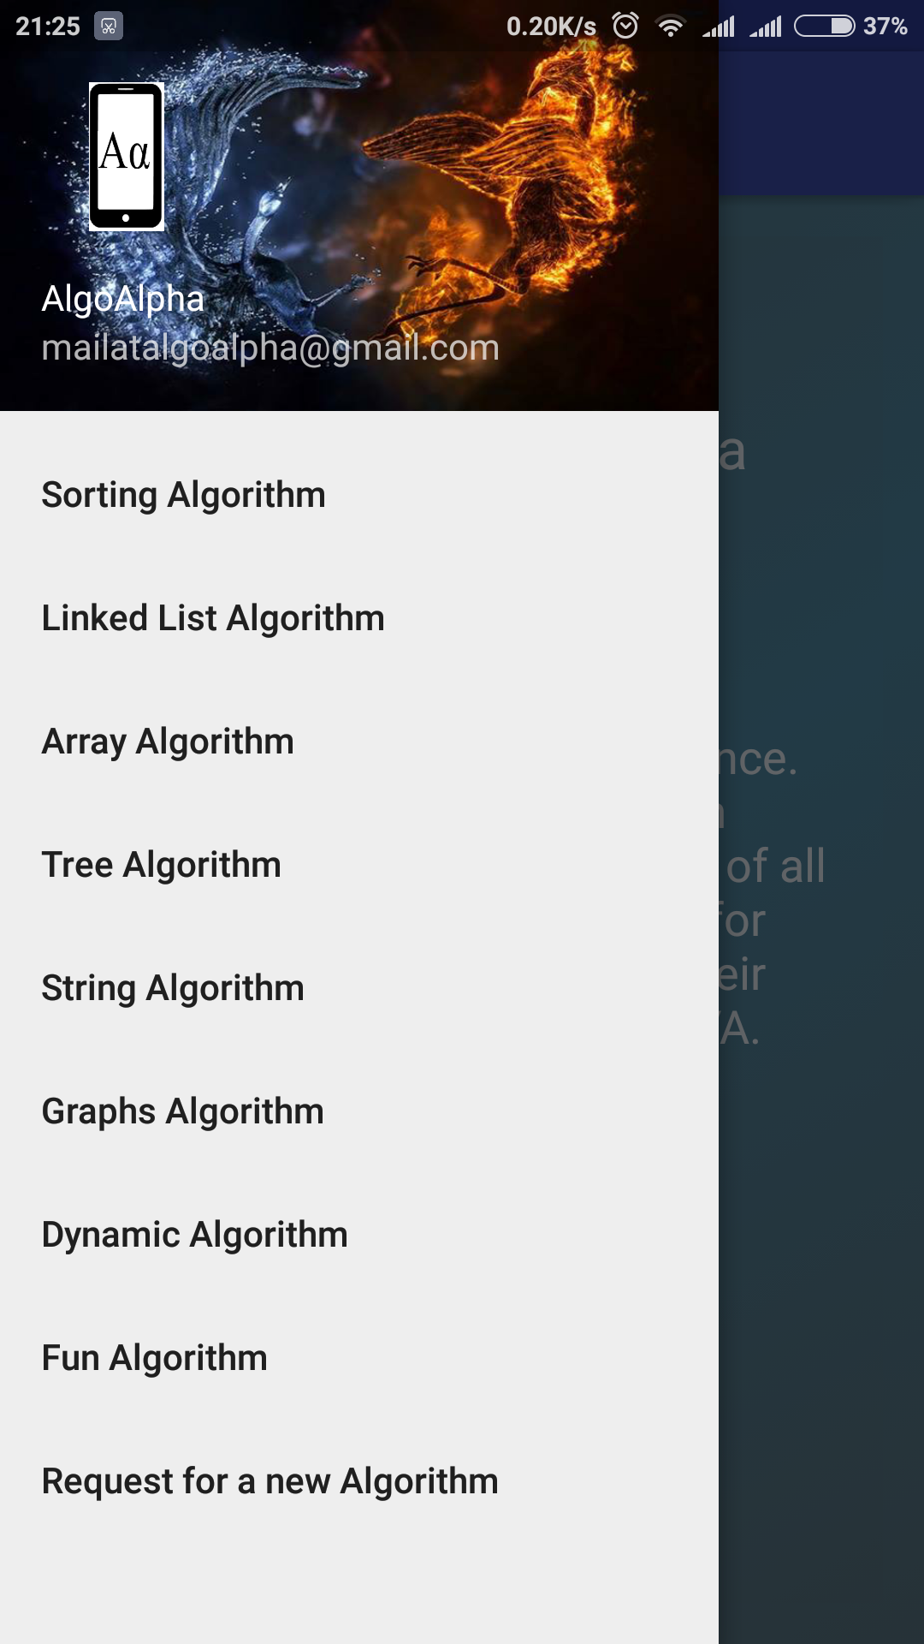
Figure 3: Navigation Bar
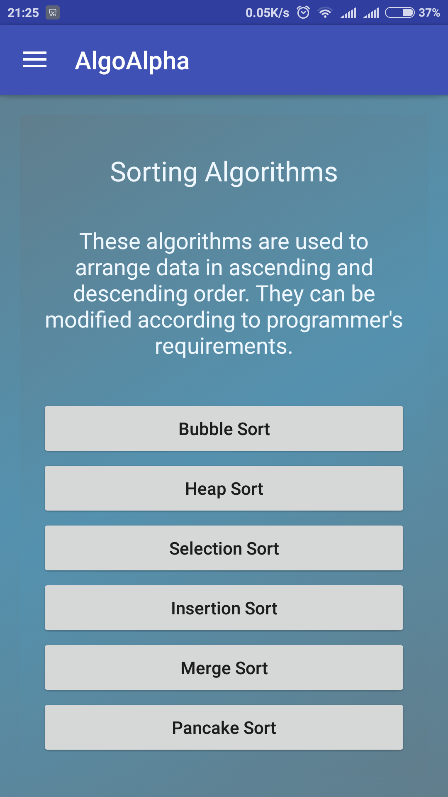
Figure 4: Sorting Algorithms Landing
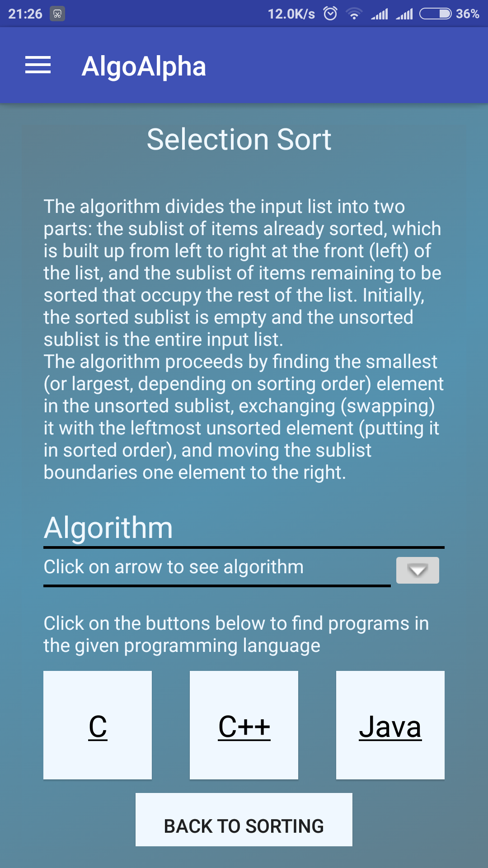
Figure 5.1: Selection Sort Landing (Algorithm Hidden)
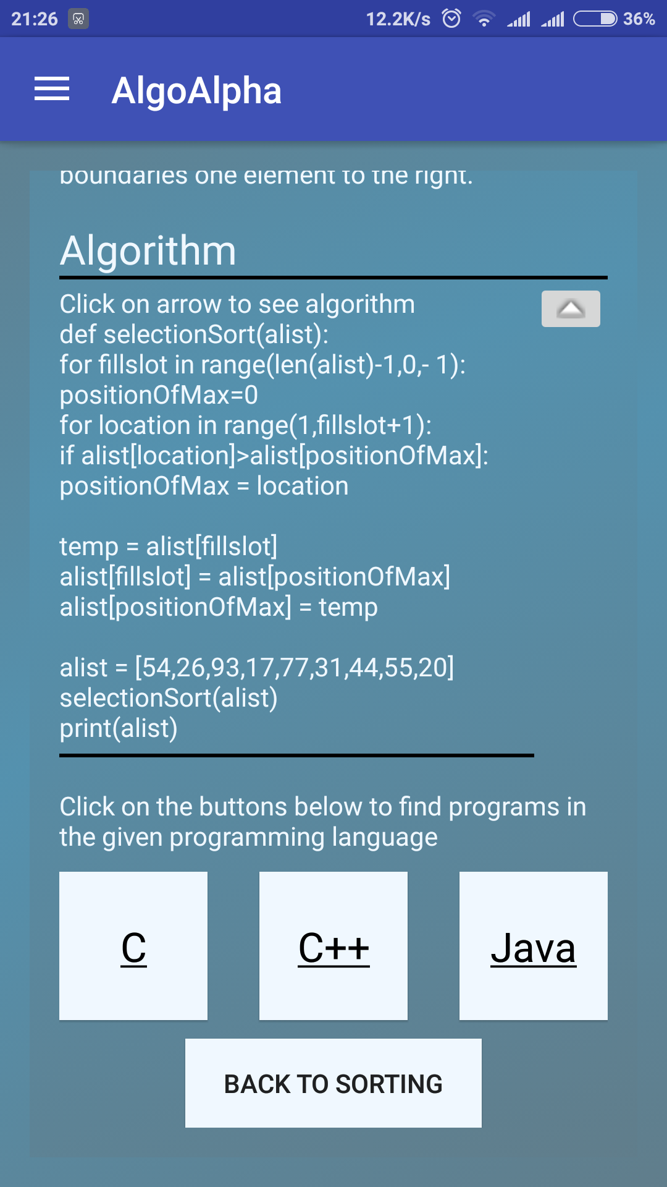
Figure 5.2: Selection Sort Landing (Algorithm Shown)

METHODS IMPLEMENTED

Android Studio:
Android Studio is the official IDE for Android application development, based on IntelliJ IDEA. On top of the capabilities you expect from IntelliJ, Android Studio offers:
- Flexible Gradle-based build system.
- Build variants and multipleapk file generation.
- Code templates to help you build common app features.
- Rich layout editor with support for drag and drop theme editing lint tools to catch performance, usability, version compatibility, and other problems.
- ProGuard and app-signing capabilities.
- Built-in support for Google Cloud Platform, making it easy to integrate Google Cloud.
- Messaging and App Engine.

RESULTS AND DISSCUSSION

The main frame of the application has been created. A user can search for the algorithms via the tabs shown, and the code via the buttons on the algorithm page. The application hasn’t been submitted to Google Play Store yet. The application is, and for the near future, will be an incomplete application. The end goal is to have an almost exhaustive algorithm database. As such, the application will be regularly updated with new algorithms.

CONCLUSION & FUTURE SCOPE

- The application is up and running.
- The Database, as of now, contains 97 unique algorithms with code for all of them.
- A search option is to be developed.
- We plan to make the app completely offline, while keeping the app size less than 10 MB.
- The app is long way from being complete and we will continue to put in effort.

REFERENCES

- Videos provided in course
- www.youtube.com
- developer.android.com
- www.google.com
- ibuildapp.com
- ww.codeschool.com

